MARKET SEGMENTATION USING CLUSTERING ALGORITHMS

  - Segmenting Customers

    - Basis of Segmentation

  - Targeting Potential Customers

  - Positioning the Product in Customers’ Minds

  - Data-Driven Segmentation

    - Behavioral Segmentation

    - Dynamic Segmentation

    - Microsegments

  - Clustering Algorithms for Segmentation

    - The Relationship Between Distance and Similarity

    - The k-Means Algorithm

    - The k-Medoid Algorithm

    - Using k-Means to Segment Customers

  - Implementation Using R: Segmentation Using k-Means and k-Medoid

  - Understanding the Chapter

SEGMENTING CUSTOMERS

LEARNING OBJECTIVES
- Understand the STPs of marketing
- Decide how to segment customers
- Learn the different bases of segmentation
- Cluster to segment customers with k-means and k-medoid
- Use k-means for finding customer segments to target
- Interpret the output of clustering analysis
Vegan-Always is a new restaurant opening in Phoenix. It wants to send out coupons to customers who enjoy vegan food. Should it send these coupons to all residents of Phoenix? While this can be done, not only would such extensive coupon distribution become very expensive, but not everyone would be interested in the restaurant’s offerings. Since not all customers are alike or share the same tastes, sending the same marketing message to everyone is not efficient or profitable. The best strategy for Vegan-Always is to divide the entire population of Phoenix in such a way that it can send the coupons only to those who are likely to visit the restaurant. One way the restaurant can do this is by using psychographics or lifestyle factors. People who are more environmentally conscious have turned to veganism and might be more interested in such a restaurant.
Similarly, demographics can be another way to find groups of customers who would be relevant for the restaurant. Such a process of dividing the market into groups of customers with similar characteristics and selecting the most appropriate group(s) for the business to target is called market segmentation. One way to think of segmentation is as a comprise between mass marketing (which assumes that all customers are the same) and individual-level customization (which assumes that all customers are unique). Instead of targeting each customer, segmentation allows a business to target groups of customers who are similar in the way they respond to the product. In today’s data-driven markets, it is now possible to segment at a deeper level; hence, microsegmenting is becoming popular. For example, based on past buying behavior and similarity to other customers, Amazon has the ability to create microsegments and recommend very specific products to each of its customers.

The first step in market segmentation is to know why customers are buying a product. What benefits is the product offering that a customer may be interested in? The business needs to identify all customer needs that a product or service can fulfill. For instance, an automobile can be purchased to satisfy transportation needs or status needs. Knowing exactly which need is being satisfied for which group of customers can help in more accurate messaging and targeting.
Identifying product-related needs can run the gamut from using traditional methods such as focus groups and surveys to the recent natural language processing (NLP) methods that can be used to mine customer opinions and reviews. Customer needs may not be restricted to just product features but may also include the company reputation. In the 1990s, Nike lost sales because of news that it was using child labor in its manufacturing units. The company had to change its working conditions because customers also wanted Nike to use the right practices. Once customers’ needs are identified, customers can be categorized into groups with similar needs that form the different segments for that business. Developing a market with an imaginary buyer whose characteristics are inaccurate is a recipe for failure. Many products have failed not because they were bad but because they were marketed to the wrong set of customers.
After businesses have grouped customers with similar characteristics in terms of how they respond to product benefits, they can then decide which of these customer groups are most profitable to target. The process of determining which of the segments offer good market opportunities is called targeting. Finally, when businesses have segmented customers and decided which of these segments to target, they need to determine how they want to position their products in the minds of their customers. Positioning can be described as instilling a meaning in customers’ minds that is unique to that product. We will first understand segmentation in detail before moving on to targeting and positioning.
Segmentation, targeting, and positioning are generally known as the STPs of marketing since these three steps tend to be conducted together.
An initial step in segmentation is to group customers by similarities in their characteristics. Customers may seek similar benefits from a product because they live in the same region. For instance, customers who share geographic similarity may face the same weather conditions; people living in colder climes may need heavier jackets that can provide warmth compared to those living in warmer places where such jackets may not be necessary.
We next discuss the different basis on which customers could be grouped together in terms of similar characteristics.

5.5.1 Basis of Segmentation
Geographic. Customers can be segmented based on where they live. For instance, an insurance company might offer different types of insurance based on whether customers are located in regions prone to tornadoes, floods, or earthquakes.
Demographic. A very common way to segment customers is by demographic features such as age, education, gender, income, and occupation. For example, businesses may target millennials differently from baby boomers. Baby boomers account for a large share of the market currently because they control a major portion of the disposable income in the United States, which makes them a very attractive segment of the market. Hence, it is important that a business planning to target baby boomers understand the features of this segment. Are they health conscious? Are they tech savvy? Would they be willing to buy online? Are they philanthropic compared to other segments? Businesses also need to keep in mind that features defining a group change with time. Women now purchase repair tools as often as men.
Psychological. Customers can be segmented based on their different psychological factors, such as motivation, personality, and perceptions. Customers can purchase a brand to satisfy a prestige motive or for a functional motive. Rolex and Timex both manufacture watches, but people might be buying them for different motives. Personality can also be used to segment customers. Companies could consider the Big 5 personality traits¹ such as whether an individual is extroverted, disinhibited, neurotic, conscientious, or open to
experience. Or a business could focus on personality traits that have been shown to affect marketplace decisions, such as impulsivity, loyalty, frugality, innovativeness, variety seeking, and risk aversion. Despite psychological factors being very informative of how customers may behave in the marketplace, it is difficult to obtain this information. Until recently, one way has been through the use of surveys, but this cannot be done for all customers and may be inconvenient and expensive. Some work has demonstrated that digital footprints of customers can be used to predict their personality. Digital footprints can be in the form of text, messages in online forums, number of likes, size of the networks frequented, and so on. Knowing the personality of customers allows for deeper customization of messages and recommendations targeting these individuals.
Sociocultural. This could include stages in the life cycle, such as whether one is single, married, or an empty nester, or social class, such as whether one belongs to the upper, lower, middle, or working class. It also could include cultural values, a very personal way that individuals define their core beliefs. Since cultural

segmentation maps onto core beliefs and values, it can help the business or brand connect with a customer at a more meaningful level. In this age of globalization, with products marketed across the world, being able to connect to unique cultures is a challenge and yet a big asset if it can be done successfully.
Psychographic. The psychographic basis of segmentation includes activities, interests, and opinions of customers. Customers who like to vacation in Yellowstone are likely to share similar interests and require different messaging tactics than those who prefer a Disneyland vacation. Customers with different political opinions (e.g., conservative versus liberal) may respond to different marketing strategies. Those who are risk averse may not be open to buying a product that is positioned as adventurous.
Benefit Sought. What kind of benefits are people likely to look for when buying a product? Let’s take the example of running shoes. They could provide more than one benefit, such as durability, comfort, speed, and appearance. They could even be used for some form of social signaling to inform others that one is a runner.
Multivitamins are another example of a product that could convey different benefits for different segments of customers—such as strength, prevention of illness, and boosting of immunity.
Usage Volume. Customers can be segmented based on how often they buy a product and how often they use it (i.e., whether they are heavy, medium, or light users). It is possible that heavy users form a smaller percentage of the total users of a product but may actually buy a substantial share of the product. Hence, they are an important segment to focus on.
Product Attitude. Having information about the type of attitude customers hold about a brand can help determine how they will react to a new or modified offering by the brand. Some customers may have extremely favorable or extremely unfavorable brand attitudes. For example, some PC users would not think of using a Mac, and vice versa. Such potentially nonconvertible customer segments may not be worth targeting.

TARGETING POTENTIAL CUSTOMERS
Segmentation reveals specific market opportunities. Once customers have been segmented based on how they respond to product features, the business needs to evaluate the customer segments and decide which to target. It rarely happens that a product has mass appeal. Therefore, finding the segments that are likely to purchase the product is important. We can understand the process of selecting

viable segments to target through the following questions that a business needs to ask.

Are there enough segments in the market worth targeting? Having a product that is liked by a very small group of customers indicates that the business may have a niche product, which may not be profitable on a broader level.
Is the segment stable, and will it remain stable for some time? It’s not ideal if the target segments are comprised of people who are interested in fads.
Growing and stable segments are more attractive and more likely to be profitable in the long term.
Are the segments accessible? For instance, a large segment of customers may be interested in the product but may be in a place where it cannot be accessed easily.
How well does this product compare with the competition in the chosen target segments? If the product is not the innovator or the first entrant in the market, chances are there are one or more businesses already catering to the segments that the business finds attractive. The business needs to find out how their product compares to existing products. If the business already has very strong competitors catering to a segment and the segment is also very brand loyal, it may be very hard to break into such a market.

POSITIONING THE PRODUCT IN CUSTOMERS’ MINDS
Positioning is defined as an effort by a business to identify a unique selling proposition that allows its product to occupy a clear, distinctive, and attractive position in the minds of target customers relative to competing products in the market. Successful positioning includes communicating the benefits of the product as well as communicating a unique selling proposition.
Many examples exist of businesses and their brands occupying a unique position in the minds of their customers. Some are so successful that the brands have become synonymous with the product category. For instance, one says Kleenex to mean facial tissue, FedEx to mean shipping, or Xerox to mean photocopying. Oral-B realized that if it wanted customers to change their toothbrushes rather than keep using worn-out ones, the company needed to communicate this to the customer. The company introduced a patented dye on the brush head that fades with usage and indicates that it is time to get a new toothbrush. Lay’s tries to

position itself on taste through its slogan of Betcha can’t eat just one, and Volkswagen positions itself by focusing on driving pleasure with its tagline Drivers wanted.
A brand can position itself based on a specific product attribute, or it can position itself in comparison to a competitor’s offering. Some automobile brands position their vehicles using product attributes; for example, Honda and Toyota focus on durability, reliability, and functional benefits while Volvo focuses on safety and Volkswagen focuses on drivability. Other automobile brands position themselves versus other brands, such as Hyundai against Toyota, to show that they offer the same or greater benefits.
We next discuss how segmentation has changed in a data-rich marketplace.

DATA-DRIVEN SEGMENTATION
As mentioned earlier, the higher volume of data available to businesses makes the following types of segmentation feasible: segmentation based on behavioral data, dynamic segmentation, and microsegmentation.

Behavioral Segmentation
In the world of Big Data, an abundance of information, including click-through and search data, is available about people’s behavior: which products they are buying, where they are buying these products, how much they are paying, whether a product is more likely to sell in specific packaging, and so on. Behavioral data can be used to extrapolate demographic and psychographic information. Many times it is difficult to find out the specific personality traits of consumers that result in their purchasing a brand (e.g., is a customer more or less frugal?). However, behavioral data, even from social media, can be used to predict the general personality of customers. Moreover, with the proliferation of online retailers, it has become easy to conduct ongoing studies to figure out customer preferences.
Instead of trying to determine the segment of customers that is most likely to purchase a brand by a study based on attitudes (e.g., how much do customers like this brand?), a product can be introduced via small samples, and actual purchase behavior can be monitored. Also, based on sales data, products can be modified in real time based on which features customers most prefer. Hence, data-driven markets allow a feedback loop by which businesses can observe actual customer purchases and fine-tune market segments.

Dynamic Segmentation

Another outcome of rich data about customers allows a business to keep updating its customer segments. Rather than segmenting all customers once and assuming that their tastes are not going to change, dynamic segmentation assumes that tastes will change and keeps updating what offering would be best preferred by a specific customer segment. Many aspects in an individual’s life can change. For example, a chocolate manufacturer cannot assume that just because a customer has purchased dark chocolate in the past they will continue to do so. Their personal, family, or health needs could change, causing them to move to buying sugar-free or nut-free chocolates. Dynamic segmentation takes into account the possibility that customer tastes change and, hence, that the segment they belong to is not static. Again, it is important that businesses hone their ability to sift through the wealth of information available to them and use the most recent information, whether behavioral or otherwise, to segment customers.

Microsegments
As mentioned earlier, it has now become possible to cater to very small segments of customers by understanding their preferences in depth and customizing products accordingly. This also leads to hyperpersonalization, where each offering uniquely targets a specific customer based on both demographic and behavioral data gathered about that customer. For instance, insurance companies can augment existing data such as age, gender, and current product portfolio with online behavior such as time spent on their website to better segment customers and offer the customer a very customized product.
As important as data are for segmentation, the algorithm chosen to perform the segmentation is equally important. Many times we just have different types of data about customers without information about a business outcome such as sales or whether or not such a customer is loyal. That is, the data tend to be unlabeled.
Because we do not have any outcome labels, we do not have the ability to compare model performances. The most common task of unsupervised learning is exploratory analysis, which uses visualization methods (the simplest being clustering) to examine the data and gather insights.
Let’s go over what algorithms are commonly used for segmentation.

CLUSTERING ALGORITHMS FOR SEGMENTATION
Clustering is frequently used to segment customers into groups with similar need sets. For instance, if we want to find out which of our customers are most likely to

recommend our product or our business, we can cluster them by similarity of attributes and try to gather insights from the clusters formed. Clustering is the process of grouping together data points that share some similarity, such that data points within a cluster are more similar to one another as well as more dissimilar to data points in a different cluster. Hence, clustering does exploratory data analysis and is considered an unsupervised algorithm because it explores data patterns rather than confirms a specific relationship. Clustering algorithms are used when the data lacks labels.
Several clustering algorithms exist, such as k-means, k-nearest neighbors, hierarchical and Gaussian mixture models, and so on; there are several types and subtypes of clustering algorithms as depicted in Figure 5.1. Clustering mainly occurs either by partitioning a large set of observations into smaller sets or by creating a treelike structure to depict the relationship between observations. In clustering, the process of dividing is called partition clustering, and k-means, k- nearest neighbors, and mixture models fall into this category. Clustering by creating a treelike structure, also called a dendrogram, involves relating each observation to another observation. Such hierarchical clustering can build up from one observation, find the nearest next observation, and so on to create a tree structure (agglomerative clustering), or it can begin by considering all observations to be in one cluster and then break down the cluster using the distance metric (divisive clustering).

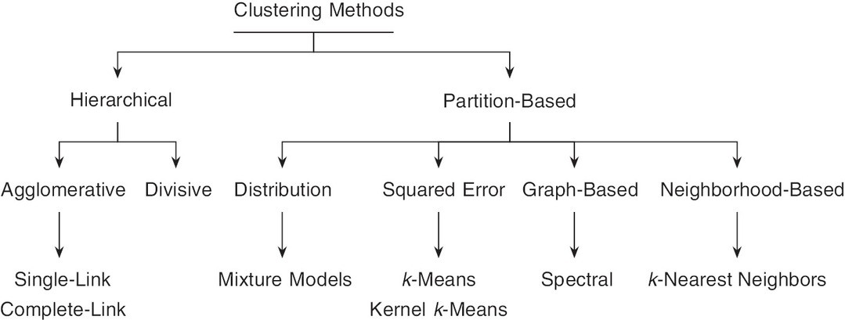

Description

Figure 5.1 Clustering Methods

We will use k-means, as well as a slight improvement—k-medoid—as clustering methods for segmentation.

The Relationship Between Distance and Similarity
The k-means algorithm is based on the intuitive notion that similar observations are likely to be clustered together. The distance between observations is a way to measure similarity: Less distance between observations implies that the observations are likely to be similar, and more distance indicates dissimilar observations. Thus, if the distance between two observations is less, it implies that the observations are similar and can be clustered together within the same cluster. If the distance between two observations is large, it implies that they are dissimilar and probably cannot be clustered together.
We next discuss how distance is used as the metric to measure similarity of the observations.
Let’s understand how distance is calculated between two observations. Assume that the two observations are from two customers and that we have information about two variables— age and income. We can use these two variables to assess the level of similarity between these two customers. If we call the two customers A and B, then the two variables can be depicted as follows for customer A:
x_{A1} = age, x_{A2} = income

And for customer B:
x_{B1} = age, x_{B2} = income

The distance between two customers (A → B) is calculated using the following formula, which is also called the Euclidean distance formula.
distance_{A→B} = √(x_{A1} − x_{B1})² + (x_{A2} − x_{B2})²
We use the two different attributes x₁ and x₂ for both A and B to find the distance between A and B. If we had information on a third customer, let’s say C, then we could determine distance measures between customers A and B, B and C, and A and C. Using this distance, we could state whether A was more similar to B or to C since less distance indicates more similarity. Clustering algorithms utilize distance as a way to group observations together. Observations that are more similar are clustered together but separately from observations that are less similar. We next discuss the most commonly used clustering algorithm, k-means.

The k-Means Algorithm
For any clustering algorithm, the goal is to find groups of similar observations among all the observations in the given dataset. To accomplish this goal, the k- means algorithm uses Euclidean distance to find out which observations are more versus less similar. But this would become a very inefficient task if we needed to find distance estimates between each observation and every other observation.
Therefore, the first step in a k-means algorithm is to decide how many clusters we, the user, want the algorithm to output. This is an issue with many clustering algorithms, where the number of clusters has to be provided by the user, and the algorithm accordingly clusters observations into the specified number of groups. For instance, if we ask the algorithm to cluster 100 observations into 5 groups, it will go ahead and do so, and if we ask it to cluster the same 100 observations into 20 groups, it will do that also. We will discuss the issue of choosing the appropriate number of clusters later.

We illustrate the steps of the k-means algorithm as follows:
1. | Randomly select k points as initial centroids
2. | repeat
3. | Assign data points to the closest centroid
4. | Recalculate the centroid of each cluster
5. | until Centroids do not change

Now let’s visually understand these steps using a figure. Figure 5.2(a) shows observations, with each point representing a customer’s age (x-axis) and income (y-axis). We set k = 3, which means we want the algorithm to assign
observations to one of the three clusters. Once we provide the number of clusters, the k-means algorithm randomly selects k locations as center points or centroids. Figure 5.2(b) shows these randomly selected centroids. The distance from each observation to each of the k centroids is measured, and then each observation is assigned to the centroid closest to it. At the end of the first iteration, each observation has been assigned to one of the k clusters. The color of the points in Figure 5.2(b) indicates their cluster membership.

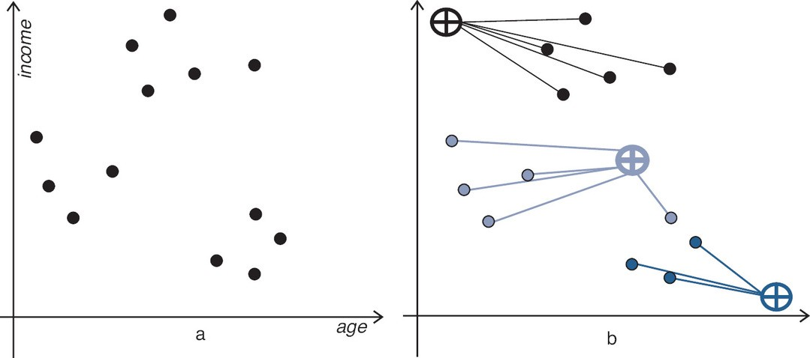

Description

Figure 5.2 k-Means

The k-means algorithm next finds the new centroids of the newly formed k clusters. Recall that a centroid is nothing but the central point of a cluster. Since the initial centroids were randomly chosen, we can see that the location of the new centroid changes (see Figure 5.3(a)). Again, the distance of each observation to these new k centroids is calculated, and the observations are reassigned to the centroid closest to it.

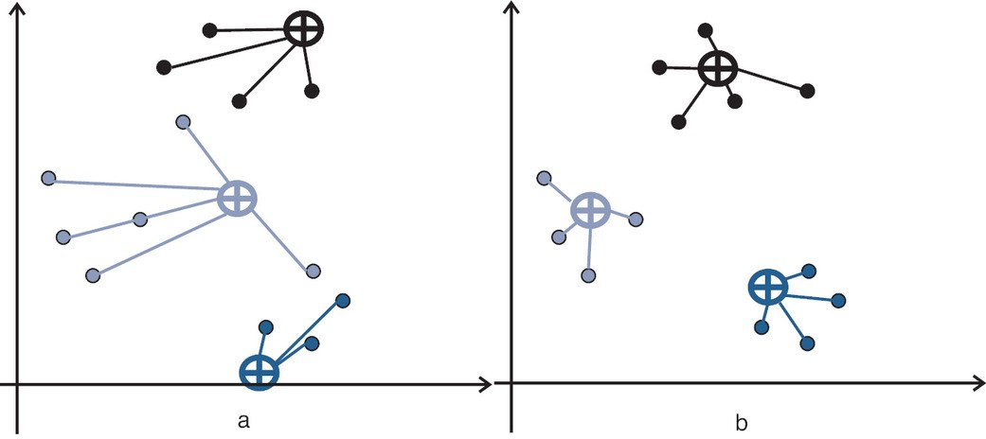

Description

Figure 5.3 k-Means After Iteration

In this next iteration, k clusters are again formed. In the subsequent iteration, centroids are calculated for these k clusters, and the process is repeated till the centroids do not change (see Figure 5.3(b)). The stability of the centroids indicates that this is the optimal allocation of observations to k clusters. If we ask for a different number of clusters, then the k-means algorithm will go through the same process until it finds the optimal allocation of observations to the number of clusters that we have specified.

The k-Medoid Algorithm
One of the issues with k-means is that outliers can influence the clusters that are generated. An improvement over the k-means algorithm is k-medoid, which modifies k-means to take care of this issue. While k-means randomly chooses centroids of various clusters, k-medoid first chooses data points as centers of clusters. Then instead of using Euclidean distance, it uses Manhattan distance to find the closest cluster center to a point. Manhattan distance is calculated by measuring the absolute distance between any two points and uses the following formula:

n
dmanhattan = ∑|xi − yi|
i=1

By using Manhattan distance to calculate the proximity of a point to a cluster center, k-medoid is less influenced by outliers and noise in the data.
An example of using k-means and k-medoid to segment customers will help us understand how the algorithm can be used for segmentation.

Using k-Means to Segment Customers
We pick an example with just two variables because it is easy to visualize, although k-means can be used for a large number of variables. (The data for this example are hypothetical.) A common query of most retail stores is whether they should target customers who spend more or customers who have been their patrons for longer (i.e., is amount of money spent or duration more important?). Therefore, we have two input variables: amount spent and duration of patronage. We first scale the data by subtracting the means and dividing by the standard deviation (details of scaling and standardization are provided in the Technical Appendix). Scaling the data prevents data distortions that would occur in clustering if the input variables are on different scales; the variable with a bigger unit would be overrepresented.
Then we tell the k-means algorithm how many clusters we want it to output. This is an important consideration for most clustering algorithms, which require that the user specify the number of clusters into which the observations need to be segmented. Here we ask it to output three clusters. Figure 5.4 illustrates the three clusters.

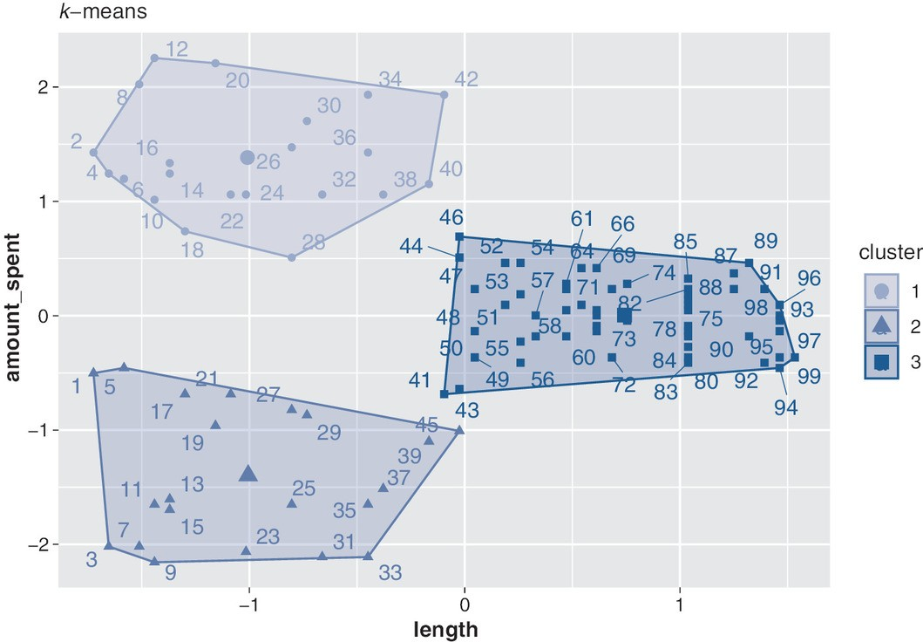

Description

Figure 5.4 k-Means Segmentation Plot

Along with the cluster, we can also instruct the algorithm to output the value of the cluster center. This information is useful for interpreting the output because it provides the average characteristics of a customer in that cluster or segment.

## | length | amount_spent
## 1 | -1.0092435 | 1.38324959
## 2 | -1.0058705 | -1.39737047
## 3 | 0.7424104 | 0.00520243

We can then interpret that members of cluster 1 have an average patronage duration of −1.009 months and have spent $1.383,² whereas members of cluster 2 have a similar patronage length to those in cluster 1 (−1.006 months) but have spent substantially more (−$1.397). One insight that the business can derive from these two segments is that customers in cluster 2 seem to spend more and might
be more profitable for the business to target. It would also be important for the business to find out what features of customers in cluster 1 make them stay for

the same duration but not spend as much. Would some form of incentive such as coupons for loyal customers motivate them to spend more?
An important question (some even call it a challenge) in any clustering analysis is knowing the best number of clusters to choose. Since we must specify the number of clusters for the algorithm, how do we know whether three or seven will be the best number of clusters? Many times it depends on the question we are trying to answer. Or we can use past information that shows the number of clusters obtained when we used similar data. A silhouette helps us answer the question of choosing the optimal number of clusters. A silhouette analysis is based on the simple intuition that if an observation is in a cluster, then that observation should be closer to those in the same cluster than to those in other clusters. A silhouette coefficient for each observation is calculated and varies between −1 and +1, with +1 indicating the best and −1 being the worst allocation to a cluster. The average silhouette coefficient for all observations is known as the average silhouette width. An average silhouette width near 1 indicates a tight cluster, with observations in the cluster close together rather than spread all over. For instance, if a four-cluster solution gives a silhouette value of 0.7, and a seven- cluster solution gives a silhouette value of 0.3, it means that the four-cluster solution is better.

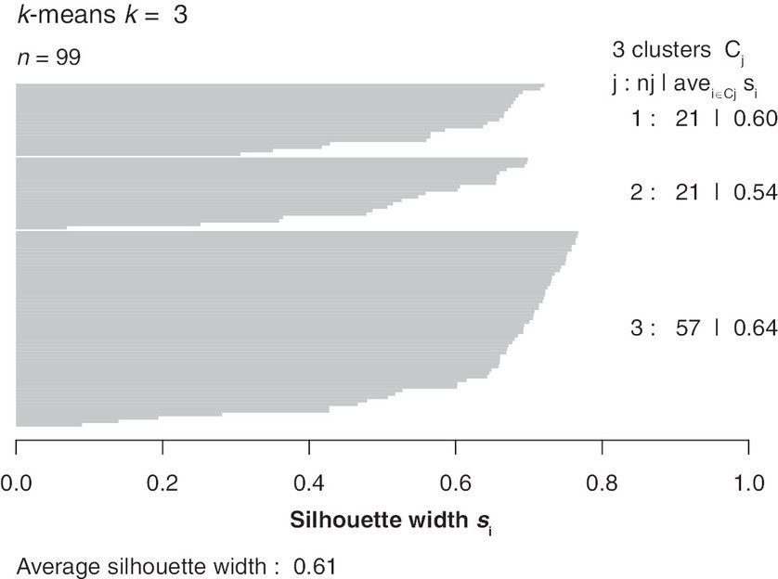

Description

Figure 5.5 Silhouette Width: k-Means

In our case, we find that with a three-cluster solution the average silhouette width is 0.61, as shown in Figure 5.5. We can try different values of k and see how the average silhouette width changes. We can next run the same analysis using k- medoid and instruct the algorithm to output three clusters (see Figure 5.6).

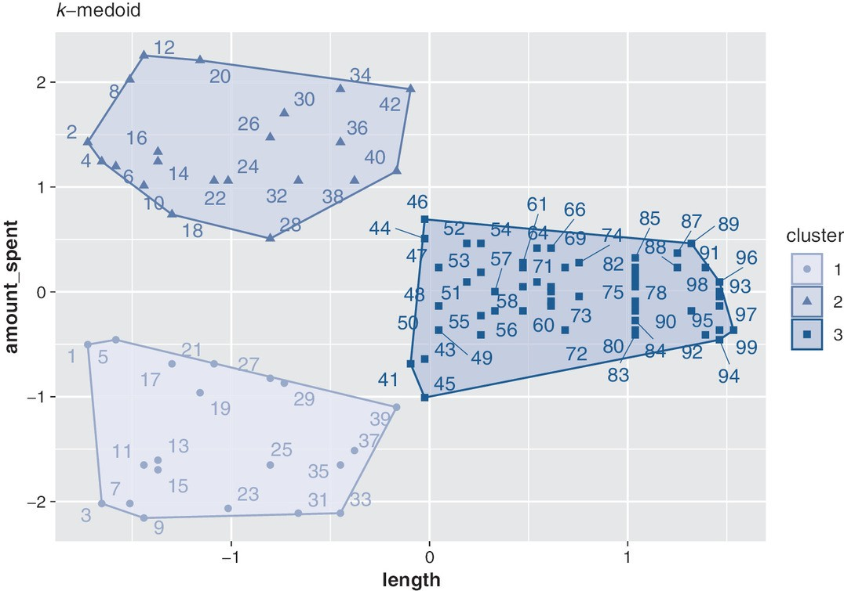

Description

Figure 5.6 k-Medoid Segmentation Plot

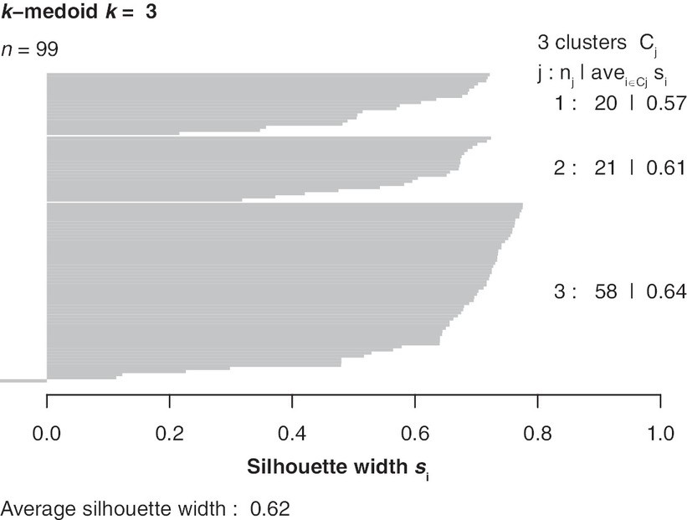

Description

Figure 5.7 Silhouette Width: k-Medoid

In this case we see that the average silhouette width using k-medoid is 0.62 (see Figure 5.7) and not much different from a k-means solution. This could be because there are not many outliers in the data. If the number of outliers increased, the k-medoid would output a better solution.
Therefore, we can conclude our clustering analysis with the following insights. When we want to perform segmentation, we can use a clustering algorithm such k-means or k-medoid. We use clustering because our data are unlabeled (i.e., they do not have an outcome label). In the example, we find that when amount spent and patronage duration are used and we ask for three clusters, we can obtain the average characteristics of customers in the three clusters. The differences between these customers inform us how the business can present effective product offerings to customers in these three segments.

IMPLEMENTATION USING R: SEGMENTATION USING K-MEANS AND K-MEDOID
To analyze and plot data, we will use two packages: cluster³ and factoextra.⁴ After importing the data, we center and scale it using the scale() function with center = TRUE and scale = TRUE options; center
= TRUE subtracts the column means of a variable from their corresponding column values, and scale = TRUE divides the (centered) columns of a variable by their standard deviations. This process converts values of each variable into their z scores. This is an important step before cluster analysis since each variable of a dataset can be measured on different scales. In our dataset, for example, duration of store patronage is measured in months, but amount spent is measured in dollars. Scaling the data ensures that there are no distortions due to difference in scales used across variables.
Once we have read and scaled the data (df), the actual code to run k-means is quite simple. In the kmeans() function, centers specifies the number of clusters ( k), then nstart = 25 sets 25 initial random centroids and selects the best one. A higher value of nstart gives more stable solutions, but for larger datasets this may end up taking more computing time.

library(cluster)
library(factoextra)
set.seed(12345) #Set seed for reproducibility
df <- read.csv(url(
"http://data.mishra.us/files/chapter_segmentation/segmentation_kmeans.csv"))
df <- scale(df,center = TRUE, scale = TRUE)
k_means <- kmeans(df, centers = 3, nstart = 25)

The following code helps produce Figure 5.4 using fviz_cluster() function. repel = TRUE prevents datapoints from lumping together and makes them readable.

fviz_cluster(k_means, data = df,
repel = TRUE,
main = "k-means segmentation plot"
)

We can also print cluster centers for each of the three clusters, as we saw in Figure 5.4. This is very helpful when our data have more than two variables and it becomes harder to plot clusters. By using cluster centers, we can assess the average characteristics of each cluster. Consistent with the plot, here our output shows that members of cluster 1 have an average patronage duration of −1.009 months and have spent $1.383, whereas members of cluster 2 have a patronage length of −1.006 months and have spent −$1.397. Due to centering and scaling, amount spent and length have negative values. Cluster numbers might change in different runs of the R code (e.g., cluster 1 may be labeled as cluster 2).

print(k_means$centers)
## | length | amount_spent
## 1 | −1.0092435 | 1.38324959
## 2 | −1.0058705 | −1.39737047
## 3 | 0.7424104 | 0.00520243
Silhouette, a tool to detect the quality of clusters, can help in estimating the right value of k. The silhouette coefficient varies between −1 and +1. An average value (also known as average silhouette width) near 1 shows a tight cluster, with observations within a cluster close together compared to observations between clusters. As the value moves away from +1 to −1, it indicates reduced within- cluster cohesion.

The following code calculates distance and generates silhouette plots, as we saw in Figure 5.5. The dist() function calculates the Euclidean distance between points (method="euclidean").

dis=dist(df, method="euclidean")
sil = silhouette (k_means$cluster, dis)
plot(sil,main=paste("K-Mean k = ", 3))
The silhouette plot shows that the average silhouette width is 0.58. We can try different values of k (or centers in the k-means calculation) to see how the

average silhouette width changes.

The following code performs k-medoid clustering on the same data. There are only two differences in this code compared to the one that produces k-means. First, instead of the k-means() function, we use pam(), which stands for “partitioning around medoids.” Second, for cluster analysis and calculation of silhouette width, we use Manhattan distance. This produces the cluster plot and silhouette width we saw in Figures 5.6 and 5.7.

k_medoid <- pam (scale(df), k = 3, metric = "manhattan")
fviz_cluster(k_medoid, data = df,
repel = TRUE,
main = "k-means segmentation plot"
)
dis=dist(df, method="manhattan")
sil = silhouette (k_medoid$clustering, dis) # for silhouette plots
plot(sil, main=paste("K-Medoid k = ",3))

Since there are not many outliers, the results of k-means and k-medoid are very similar.

UNDERSTANDING THE CHAPTER
Students are encouraged to answer the following questions. They can then review the chapter to check their answers.
- If a car manufacturer customizes features of the car based on the terrain, which type of segmentation is the manufacturer using?
- Which of the following characteristics is true about segmentation?
  - Having a unique selling proposition
  - Positioning the product in the minds of the customers
  - Grouping together customers based on similar need sets
  - Grouping together customers based on opposite need sets
  - Communicating the benefits of the product through coupons
- Can a business having global operations ignore sociocultural aspects while advertising the product in different world regions?

- Would it be advisable for a business to target a segment of consumers that many of its competitors are also targeting because that set of customers has the maximum likelihood of purchasing the product? Discuss pros and cons of such a strategy.
- How can a business determine the optimal number of segments in which to group customers if it is using a k-means algorithm?
- How does a k-medoid algorithm improve clustering over the k-means algorithm?

ENDNOTES

- Costa, P. T., and R. R. McCrae, “The Revised Neo Personality Inventory (NEO- PI-R),” The SAGE Handbook of Personality Theory and Assessment 2, no. 2 (2008): 179–198.
- Due to centering and scaling, amount spent and length have negative values.

- Maechler, M., P. Rousseeuw, A. Struyf, M. Hubert, and K. Hornik, “cluster: Cluster Analysis Basics and Extensions,” R package version 2.1.2 (2021).

- Kassambara, A., and F. Mundt, “factoextra: Extract and Visualize the Results of Multivariate Data Analyses,” R package version 1.0.7, April 1, 2020, https://CRAN.R-project.org/package=factoextra.

Descriptions of Images and Figures
Back to Figure

The figure is a flow chart consisting of four lines denoted by downward arrows. On top is Clustering Methods. In the second line are Hierarchical and Partition- Based. In the third line are Agglomerative and divisive under Hierarchical. The terms Distribution, Squared Error, Graph-Based and Neighborhood-based are under Partition-based. In the fourth row Single-Link Complete-Link under Agglomerative, Mixture Models under Distribution, k-Means Kernel x-Means under Squared Error, Spectral under Graph-based and k-Nearest Neighbors under Neighborhood-based.
Back to Figure

The figure has two graphs. The first graph is labeled income on the y-axis and age on the x-axis. The graph has five circular nodes scattered on top, four nodes on middle left and four nodes on the bottom right. On the right is the same graph with a circle and a horizontal and a vertical line intersecting the circle on top left

connecting five nodes on the top with a straight line. At the middle is a circle connecting four nodes on the left and a node at the bottom. At the bottom right is a circle connecting three nodes on the top.
Back to Figure

The figure has two graphs. The graph has five circular nodes scattered on top, five nodes in middle and three nodes at the bottom in the middle. Each group is connected to a circle and a horizontal and a vertical line is intersecting the circle. On the right is the same graph with five circular nodes connected to a circle with a horizontal and a vertical line intersecting the circle on top middle; and four circular nodes at the bottom middle connected to a circle with a horizontal and a vertical line intersecting the circle.
Back to Figure

The figure is a graph with the label amout_spent on the y-axis and label length on the x-axis. The term k-means is at the top left. Three groups of clusters are present in the graph. On the top left is a cluster with circular nodes; on the middle right is a cluster with square nodes and on the bottom left is a cluster with rectangular nodes. On the right is the figure legend with three different clusters labeled 1, 2 and 3.
Back to Figure

The figure consists of the scale marked 0.0, 0.2, 0.4, 0.6, 0.8, 1.0 from left to right and labeled Silhoutte width s₁. Above the scale are three area plots from left to right. On the top left is the description k-means k = 3 n = 99. On the top right is the description 3 clusters Cj j:nj l avei ∈ Cj si. On the right side are the descriptions
1: 21 | 0.60, 2: 21 | 0.54 and 3: 57 | 0.64 from top to bottom. At the bottom left of the figure is the description Average silhouette width : 0.61.
Back to Figure

The figure is a graph with the label amout_spent on the y-axis and label length on the x-axis. The term k-medoid is at the top left. Three groups of clusters are present in the graph. On the top left is a cluster with circular nodes; on the middle right is a cluster with square nodes and on the bottom left is a cluster with rectangular nodes. On the right is the figure legend with three different clusters labeled 1, 2 and
Back to Figure

The figure consists of the scale marked 0.0, 0.2, 0.4, 0.6, 0.8, 1.0 from left to right and labeled Silhoutte width s₁. Above the scale are three area plots from left to right. On the top left is the description k-medoid k = 3 n = 99. On the top right is the description 3 clusters Cj j:nj l avei ∈Cj si. On the right side are the descriptions
1: 20 | 0.57, 2: 21 | 0.61 and 3: 58 | 0.64 from top to bottom. At the bottom left of the figure is the description Average silhouette width : 0.62
OceanofPDF.com

